Name: _____________________ Class:__________ Date:__________
Instructions: Write answers in the right-hand column. Score: ___________ / 50 marks
Section A— Multiple choice (10 marks)

 | Where organisms live together and both benefit from the relationship, the interaction is classified as:  - mutualism  - commensalism  - competition  - parasitism | A | 1
2 | Producers are vital in ecosystems because:  - they can make the food materials they need  - animals can consume them  - they can use sunlight to use up carbon dioxide  - they are the only organisms that can make food materials | D | 1
3 | Which reaction introduces chemical energy into the ecosystem and therefore supports almost all the life on Earth?  - respiration  - photosynthesis  - breathing  - decomposition | B | 1
4 | Some materials can be harmful to the organisms in the food web. Which of the following explains why DDT is particularly dangerous in food webs?  - It kills insects when it is sprayed on them.  - It accumulates and concentrates while passing along a food chain.  - It becomes more poisonous when it passes through a living thing.  - DDT is a toxic chemical and any toxic chemical is dangerous to use. | B | 1
5 | Look at the food chain shown. Using the information in the food chain, determine which statement is NOT a correct inference.  clover → caterpillar → lizard → kookaburra  - The lizard consumes the caterpillar.  - The clover is the producer.  - The kookaburra is dependent on the clover.  - There would be a greater mass of kookaburras than lizards. | D | 1
6 | When green plants capture light energy they make glucose. Most of this glucose is then used in:  - respiration  - making new cells  - growing  - photosynthesis | A | 1
7 | From the following lists, choose the one that only contains physical (abiotic) factors.  - rainfall, sunlight, competition, soil nutrients  - temperature, wind speed, predation, humidity  - soil moisture, sunlight, air temperature, soil texture  - pollination, parasitism, humidity, soil humus content | C | 1
8 | Choose which of the following best describes what ecologists study.  - interactions between organisms that affect their survival  - a list of the organisms in a community and their abiotic surroundings  - the biotic and abiotic factors in a habitat that affect survival  - the interactions between organisms and their non-living surroundings | D | 1
9 | The chemical reactions of photosynthesis involve:  - oxygen and water combining to form sugar and carbon dioxide  - carbon dioxide and water combining to form sugar and oxygen  - oxygen and carbon dioxide combining to form sugar and water  - carbon dioxide and sugar combining to form oxygen and water | B | 1
10 | A community consists of:  - the organisms in an ecosystem and their physical surroundings  - the habitat and environment of all the different populations in an ecosystem  - all the organisms in an ecosystem  - the habitat and abiotic factors in an environment | C | 1

Section B— Short answer (30 marks)

- ` | Examine the food chain shown below.  water weed → tadpole →  moorhen → swamp harrier  For this food chain, identify the:  a producer  b herbivore  c third order consumer | a water weed  b tadpole  c swamp harrier | 3
 | Define biodiversity and give one reason why it is important in a sustainable natural ecosystem. | High biodiversity means lots of species in an ecosystem.  Biodiversity allows the ecosystem to resist environmental changes such as variations in weather and invasion by foreign species. | 2
 | Demonstrate how frogs would be affected by both the biotic and abiotic environments. | Frogs lay eggs in water and these hatch into tadpoles. Without the water they cannot reproduce. Water is an abiotic factor.  Frogs are eaten by birds and snakes, which are biotic factors. | 2
 | Consider the food chain shown below.  leaves → caterpillar  honeyeater → brown hawk  The total energy in the leaves is much greater than the energy received by the hawk. Describe the main reason why energy in the cells of the leaves may not reach the hawks. | At each link in the chain, the organism uses most of the energy in its food in maintaining itself. Only about 10% ends up stored in its body cells. So at each link, 90% of the energy is lost to the next link. | 3
 | Describe four major ways in which humans damage ecosystems. | Any four such as:  Habitat destruction – clearing land to build and grow food removes habitat for native species.  Introduced species – compete with native species, prey on them or destroy habitat.  Pesticides – can kill beneficial species and may accumulate in food webs.  Overcropping – removing more individuals from the population than can be replaced by breeding.  Chemical pollution – toxic chemicals that kill species. | 4
 | Compare how matter and energy flow through an ecosystem. | Matter recycles – decomposers return the material to the soil and air for reuse by plants.  Energy does not recycle – it is progressively lost along food chains. | 2
 | Clarify two reasons why natural ecosystems should be protected. | Any two of:  Survival – destroying natural ecosystems could destroy our life support systems such as food crops and fish stocks.  Economics – they can earn money via tourism or may supply us in the future with new chemicals for medicines, etc.  Culture – they contain species that are part of our national identity such as kangaroos and emus.  Compassion – only humans understand the threat to life on the planet so we have a responsibility to protect it. | 4
 | Consider the following diagram showing oxygen changes in a lake over a day.  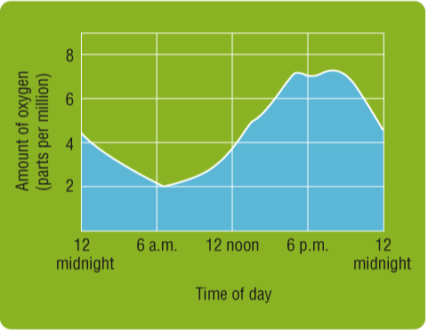  Propose why the amount of oxygen changes in the lake over the day, mentioning both photosynthesis and respiration in your answer. | During the day plants photosynthesise, releasing oxygen.  Consumers respire all day and night, using oxygen.  During the day the amount produced must be greater than the amount consumed. (Or could say: Therefore the amount of photosynthesis is greater than respiration.) | 3
 | Eucalypts are adapted to withstand fires and yet they have some features that encourage fires to spread.  a Identify two features of eucalypts that enable them to survive fires.  b Identify two features of eucalypts that encourage fires to spread.  c Explain how these features together can explain the success of eucalypts as a dominant plant of the Australian vegetation. | a thick bark, lignotubers (underground stems)  b oil glands in the leaves, stringy bark that hangs down to the ground  c Eucalypts can survive the fires better than other plants so encouraging the fires to spread removes the competing plants so that eucalypts can regrow much quicker and take over the area. | 4
 | Explain why decomposers are vitally important in a sustainable ecosystem. | They recycle chemicals between the living and non-living environments.  For example, they return chemicals that are needed by producers to the soil. This keeps the ecosystem functioning because it will not run out of resources. | 3

Section C— Thinking scientifically (10 marks)

 | A soil sample was analysed and four species of animal were found. The approximate numbers of each animal in the soil sample are shown below.  species W: 2 000 000  species X: 2  species Y: 2000  species W: 20 000  Deduce which species is likely to be the highest order consumer.  - W  - X  - Y  - Z | B | 1
 | Consider the food chain shown below.  wheat → mouse → snake → kookaburra  If the wheat eaten by the mouse contains 1000 units of energy, calculate approximately how many units of energy will the kookaburra receive.  - 1  - 10  - 100  - 1000 | B | 1
 | Consider the food chain shown below.  phytoplankton → zooplankton → small fish → large fish → sea eagles  Identify which of the following correctly describes the role of the zooplankton and large fish. | C | 1
   | zooplankton | large fish
  A | producer | third order consumer
  B | first order consumer | fourth order consumer
  C | first order consumer | third order consumer
  D | second order consumer | fourth order consumer
 | Identify which of the following is a structural adaptation of a kangaroo.  - On very hot days it licks its forearms to allow them to cool by evaporation.  - It hides in caves or under trees on hot days.  - It digs to find water in dry creek beds.  - It has a long heavy tail that balances its body when it hops. | D | 1
 | Many fish, such as sharks and barracuda, are often streamlined, meaning they are very smooth and shaped a bit like a bullet. Identify the physical factor that this adaptation helps them cope with.  - Water is quite ‘thick’ compared with air and is hard to swim through.  - Water is cold and fish need a small surface in contact with it so they don’t freeze.  - Predators cannot see them well if they are long and thin.  - Fish can hide from predators in narrow spaces if they are long and thin. | A | 1
 | The following table compares the physical factors in a rain forest with a beach sand dune environment.  Identify which the type of plant would grow best in a beach environment.  - a fern that requires a lot of moisture and that dries out easily in the wind  - a plant with very fast-growing underground stems that can tolerate drying out and being buried  - a fast-growing tree that requires moderate soil moisture, can tolerate salt but that does not survive being battered by wind-blown particles  - a climbing vine that grows in the shade and needs very high humidity in the air | B | 1
  Physical factor | Rain forest | Beach sand dunes
  Soil movement | Soil fairly stable – plants do not become buried | Soil moves around rapidly burying plants
  Salt content | Low salt content in soil | High salt content soil
  Soil water | Lots of moisture | Very little moisture
  Soil fertility | Moderate to low in nutrients | Low in nutrients
  Wind | Wind speed low | Strong winds
 | Following are some strategies that help solve some environmental problems. Identify which strategy correctly matches to the problem it solves. | B | 1
  Answer | Strategy | Environmental problem solved
  A | Organic farming | Introduced species
  B | National parks and reserves | Habitat destruction
  C | Quarantine laws | Chemical pesticides
  D | Biological control | Overcropping
 | Two species of water animal were placed in a tank and the numbers of each were recorded over two weeks. The population sizes are shown in the graph below.  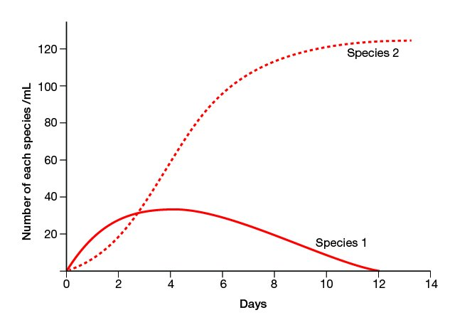  Propose which of the following seems a reasonable deduction.  - Species 1 ate species 2.  - Species 2 ate species 1.  - Both species 1 and 2 were eaten by a predator.  - Species 1 and 2 were in competition. | D | 1
 | Consider the graph shown below that shows the changes in population size of two different organisms that live in water. Propose which of the following seems a reasonable deduction.  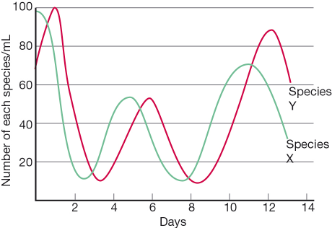  - Species X ate species Y.  - Species Y ate species X.  - Both species X and Y were eaten by a predator.  - Species X and Y were in competition. | B | 1
 | Consider the following food web.  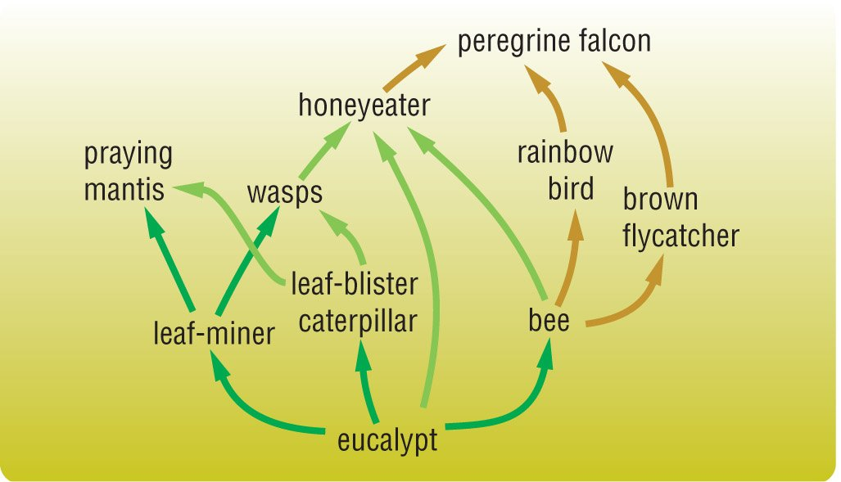  If there were a disease that killed most of the leaf blister caterpillar population, choose which of the following is the most likely effect on the food web.  - The number of bees would increase.  - The biomass of eucalypts would decrease.  - Wasp numbers would decline.  - More leaf miners would survive. | C | 1

